Packet Tracer - Troubleshoot Connectivity Issues - Physical Mode

# Topology

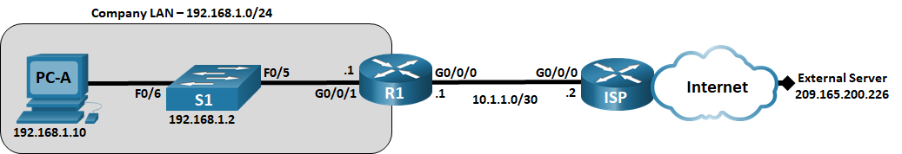

# Addressing Table

|  |  |  |  |  |
| --- | --- | --- | --- | --- |
| Device | Interface | IP Address | Subnet Mask | Default Gateway |
| R1 | G0/0/0/1 | 192.168.1.1 | 255.255.255.0 | N/A |
| R1 | G0/0/0 | 10.1.1.1 | 255.255.255.252 | N/A |
| ISP | G0/0/0 | 10.1.1.2 | 255.255.255.252 | N/A |
| ISP | Lo0 | 209.165.200.226 | 255.255.255.255 | N/A |
| S1 | VLAN 1 | 192.168.1.2 | 255.255.255.0 | 192.168.1.1 |
| PC-A | NIC | 192.168.1.10 | 255.255.255.0 | 192.168.1.1 |

Blank Line - no additional information

# Objectives

Part 1: Identify the Problem

Part 2: Implement Network Changes

Part 3: Verify Full Functionality

Part 4: Document Findings and Configuration Changes

# Background / Scenario

In this Packet Tracer Physical Mode (PTPM) activity, the company that you work for is experiencing problems with their LAN. You have been asked to troubleshoot and resolve the network issues. In Part 1, you will connect to devices on the LAN and use troubleshooting tools to identify the network issues, establish a theory of probable cause, and test that theory. In Part 2, you will establish a plan of action to resolve and implement a solution. In Part 3, you will verify that full functionality has been restored. Part 4 provides space for you to document your troubleshooting findings along with the configuration changes that you made to the LAN devices.

# Instructions

## Identify the Problem

The only available information about the network problem is that the users are experiencing slow response times and that they are not able to reach an external device on the internet at IP address 209.165.200.226. To determine probable cause(s) for these network issues, you will need to utilize network commands and tools on the LAN equipment.

**Note**: The username **admin01** with a password of **cisco12345** will be required to log on to the network equipment.

### Troubleshoot the network.

Use the tools available to you to troubleshoot the network, keeping in mind that the requirement is to restore connectivity to the external server and the eliminate slow response times.

### Document the probable causes.

List the probable causes for the network problems that employees are experiencing.

The Default Gateway is not set on the PC.

S1 Interface F0/5 is set to half duplex and speed set to 10.

S1 default-gateway set to 192.168.1.0

R1 G0/0/1 speed set to 100 and auto negotiation is disabled.

The Gateway of last resort is not set on R1.

Type your answer here.

## Implement Network Changes

You have communicated the problems that you discovered in Part 1 to your supervisor. She has approved these changes and has requested that you implement them.

## Verify Full Functionality

Verify that full functionality has been restored. PC-A, S1, and R1 should be able to reach the external server, and ping replies from PC-A to the external server should exhibit no significant variation in response times.

## Document Findings and Configuration Changes

Use the space provided below to document the issues found during your troubleshooting and the configurations changes made to resolve those issues.

Documentation will vary but should include the date when troubleshooting was conducted, devices that were tested, commands used along with the output generated by those commands, issues found, and configuration changes made to resolve those issues.

ype your answers here.

# Reflection Question

This Packet Tracer Lab Companion had you troubleshoot all devices before making any changes. Is there another way to apply the troubleshooting methodology?

Another way the troubleshooting methodology could be applied would be to complete all 6 steps on a device before moving on to another device. After you determined that the default gateway was not set on the PC, you would add the default gateway setting and verify functionality. If network issues still exist, you would then move on to the next device, S1. When the troubleshooting process had been completed on S1 and issues still exist, you would then move on to R1. This process would continue until full network functionality was achieved.

Type your answers here.

1. End of document

End of document